National University of Computer and Emerging Sciences



**Laboratory Manuals**

*for*

**Computer Networks - Lab**

(CL -3001)

|  |  |
| --- | --- |
| Course Instructor | Dr. Arshad Ali |
| Lab Instructor | Mr. Usama Khan  Mr. Muzammil Muneer |
| Section | BCS-5C |
| Semester | Fall 2023 |

*Department of Computer Science*

*FAST-NU, Lahore, Pakistan*

**Lab Manual 11**

# Objective:

* Understanding of Subnetting
* Using Cisco Packet Tracer

**INTRODUCTION TO PACKET TRACER**

* **What is Packet Tracer?**

Packet Tracer is a protocol simulator developed by *Dennis Frezzo* and his team at Cisco Systems. Packet Tracer (PT) is a powerful and dynamic tool that displays the various protocols used in networking, in either Real Time or Simulation mode. This includes layer 2 protocols such as TCP and UDP. Layer 3 protocols such as IP, ICMP, and ARP, RIP, EIGRP and layer 4 protocols such as Ethernet and PPP (Point-to-Point Protocol). Routing protocols can also be traced.

* **Purpose:**

The purpose of this lab is to become familiar with the Packet Tracer interface. Learn how to use existing topologies and build your own.

**Introduction to the Packet Tracer Interface**

**STEP 1**: Start Packet Tracer and Entering Simulation Mode

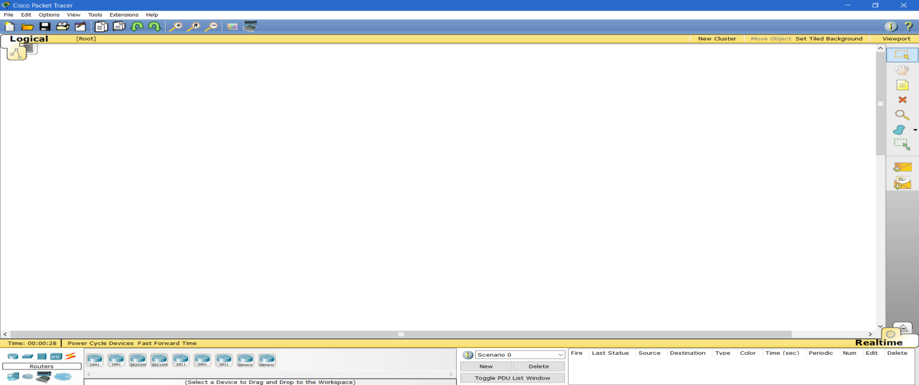

**STEP 2: Choosing Devices and Connections**

We will begin building our network topology by selecting devices and the media in which to connect them.  
Several types of devices and network connections can be used. For this lab we will keep it simple by using **End Devices, Switches, and Links.**

**STEP 3: Single click on each group of devices and connections to display the various choices.**

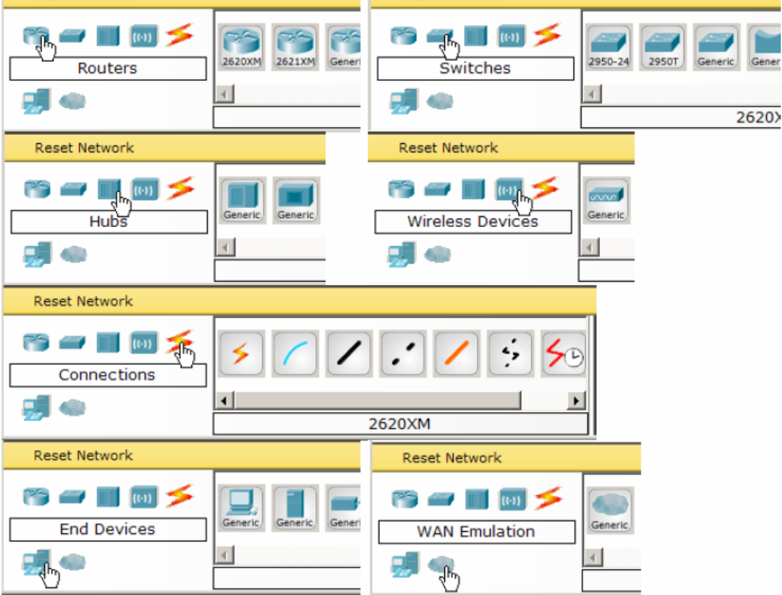

**STEP 4: Building the Topology – Adding Hosts**

Single click on the End Devices.

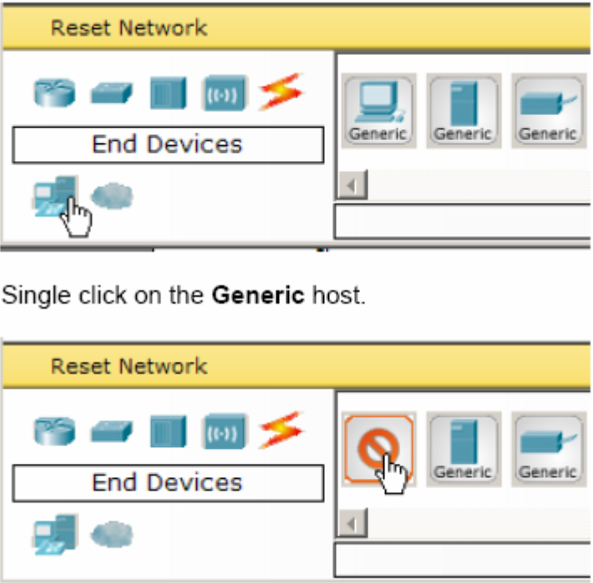

**STEP 5:**

Drag and Drop the end devices in simulation area. Similarly Drag and Drop the router for communication. We will use CISCO 2811 router because it’s the latest one from CISCO.

**STEP 6:**

Now you have to connect those end devices to router in order to make a network topology.

For connection we normally use **three types of cable**.

* **Straight through Cable:** When we have to connect UNLIKE devices.
* **Crossover:** When we have to connect LIKE Devices.
* **Serial Cable**: When we connect two Routers.

**INFO:**

Data can travel over a cable only if the two dots on it are green. However, when you connect the cables you will see the switch side turning orange. This is because the switch is doing some checks before turning on the interface, so you just have to wait (or fast-forward the time). The dot indicating the port-status refers to the interface status of the closest device. It can be of three different colors.

* **Green** – the port is working at OSI layer 1 and 2
* **Orange** – the port is powered on, but software is blocking it
* **Red** – the port is shut down

Once your ports become green, you are ready to see how we configure devices in Cisco Packet Tracer.

# IN LAB STATEMENT 1: (10)

Steps to create a network using cisco packet tracer:

1. Take **8 GENERIC PC’S** (total 8 PCs, 4 on one network and 4 on another network) that will be connected by **2 SWITCHES 2950-24**, Use drag and drop method. All the devices can be found in the bottom bar.
2. Connect all of them with **COPPER STRAIGHT** through cable.
3. If 2 computers want to communicate in a network they must have same type of subnet mask (they must have their network bits same). So Assign IP addresses to the PCs. Different network of addresses for both the sides.
   1. Double click on Pc
   2. Go to desktop tab and click “ip configuration”
   3. Insert ip of the 1st pc, subnet will automatically generate and leave the gateway right now.
   4. You need to limit yourself **to one class of private addresses**, if you want to computers to talk with each other within a network
4. **Connecting Network With One Router**
   1. Connect **ONE GENERIC ROUTER**
   2. Connect It With Switch 0 from fast Ethernet 0/0
   3. Connect It With Switch 1 from fast Ethernet 1/0
   4. Use Copper straight through cable
5. **Router connected with the network 1 from fast Ethernet 0/0**
   1. Double click on router
   2. Go to “config” tab
   3. Click fast Ethernet 0/0.
   4. Insert ip of the class as the network 1 have, subnet will automatically generate  
      make sure port status on
   5. Add corresponding gateway in all PCs
6. **Router connected with the network 2 from fast Ethernet 1/0**
   1. Double click on router
   2. Go to “config” tab
   3. Click fast Ethernet 1/0.
   4. Insert ip of the class as the network 2 have, subnet will automatically generate  
      make sure port status on
   5. Add corresponding gateway in all PCs
7. **Pinging:** Go to the command prompt of any pc and ping any address in the network. If the address is correct you should get the reply packet from that PC.
8. **Simulation Mode:** You can also go to simulation mode and make the real packet travel from one PC to another PC.



# IN LAB STATEMENT 2: (10)

The Dynamic Host Configuration Protocol (DHCP) is a network protocol that is used to configure network devices. DHCP allows a computer to join an IP-based network without having a pre-configured IP address. DHCP is a protocol that assigns unique IP addresses to devices, then releases and renews these addresses as devices leave and re-join the network.

Internet Service Providers (ISPs) usually use DHCP to allow customers to join the Internet with minimum effort. The DHCP server maintains a database of available IP addresses and configuration information. When it receives a request from a client, the DHCP server determines the network to which the DHCP client is connected, and then allocates an IP address. DHCP servers typically grant IP addresses to clients only for a limited interval.

Now you have to apply DHCP on Packet Tracer

* **Make a topology with one router on which we will apply DHCP and several client PCs. More like this one,**

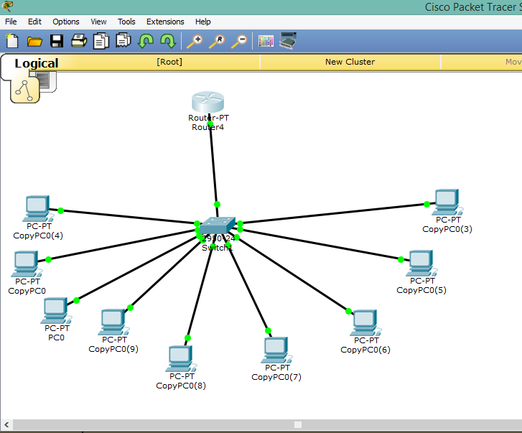

You have to manually configure the Router which will assign dynamic ip addresses to your PCs.

🡪 Open Command Line Interface of the Router

🡪 Enter “No” if it demands for configuration settings. “Continue with configuration dialog? [yes/no]: no”

🡪 Next step is to enable the DHCP service on our router by typing the following command

**Router>enable //to enable the router configuration**

🡪 Now start configuration



**Router#configure terminal //to configure the terminals of router**

🡪 It will prompt following lines 

**Enter configuration commands, one per line. End with CNTL/Z.**

🡪 Now enter following commands, one per line

//select interface

//assign address

//port status on

//exit interface

🡪 **For DHCP configuration**



**Router(config)# ip dhcp pool *name***

🡪 **To assign IPs starting from IP=192.168.1.2**

**Router(dhcp-config)# network 192.168.1.2 255.255.255.0**

🡪 **Default Gateway of all**



//exit DHCP config

🡪 If you want to reserve some addresses for further use, enter command “ip dhcp excluded addresses x-x”, (where x is the starting and ending IP address respectively)



🡪 Else enter



🡪 It will prompt following lines:



🡪 Now, open the PC.

🡪 Click on IP Configuration

🡪 Select from Static to DHCP

🡪 And after DHCP request is completed you will see the following screen.

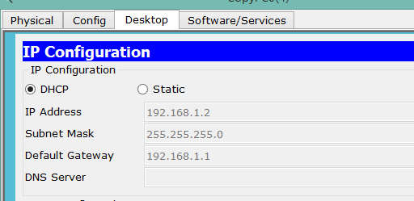

It shows that you have configured the IP through DHCP.

**Links**

<https://www.youtube.com/watch?v=_ISu9f8ofZk>

<https://www.youtube.com/watch?v=DqU3KVCyFNg>